Task 1

**The Project**

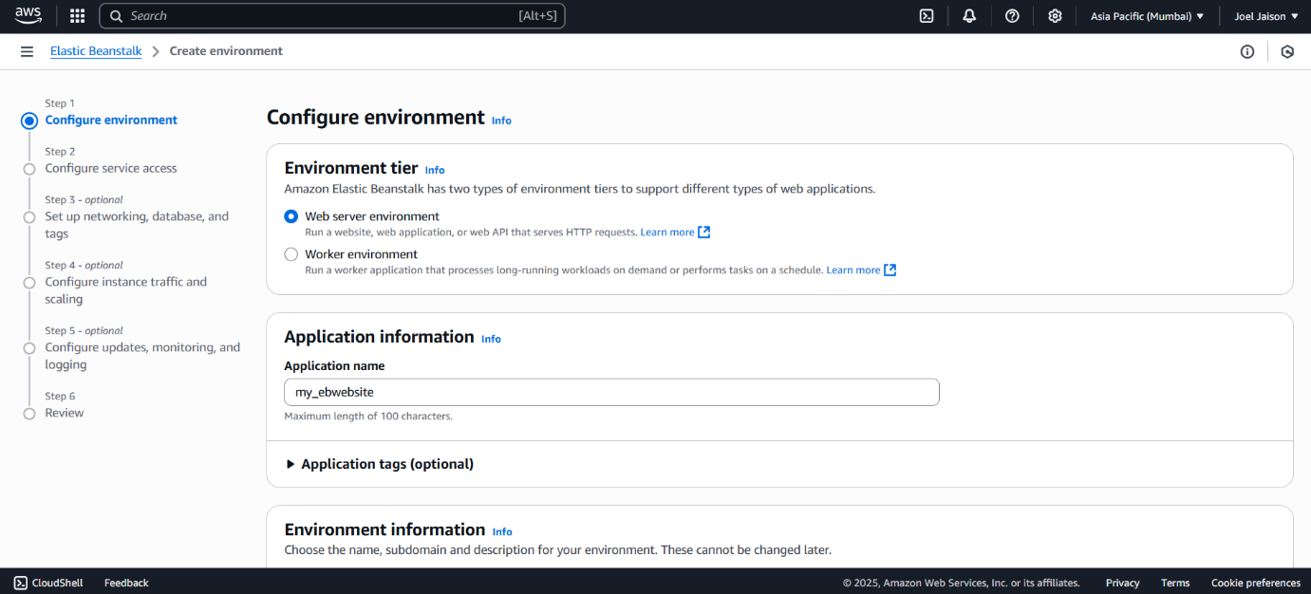

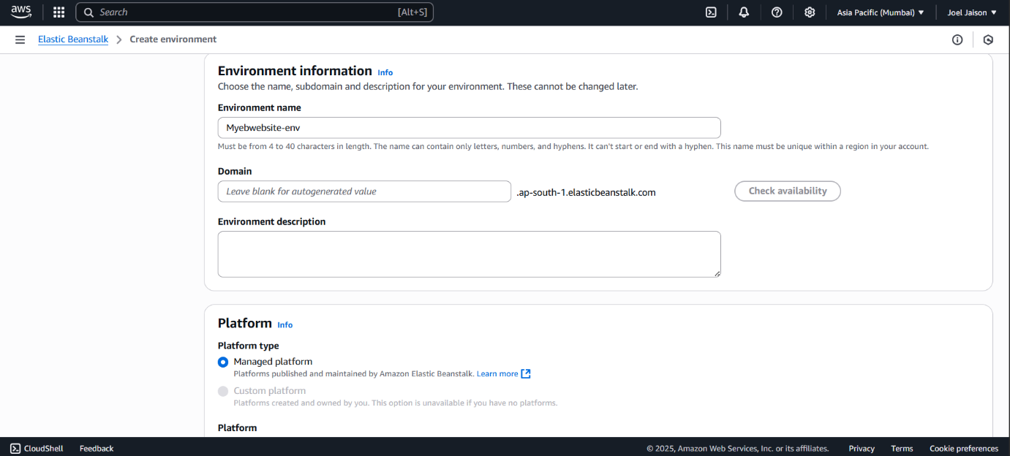

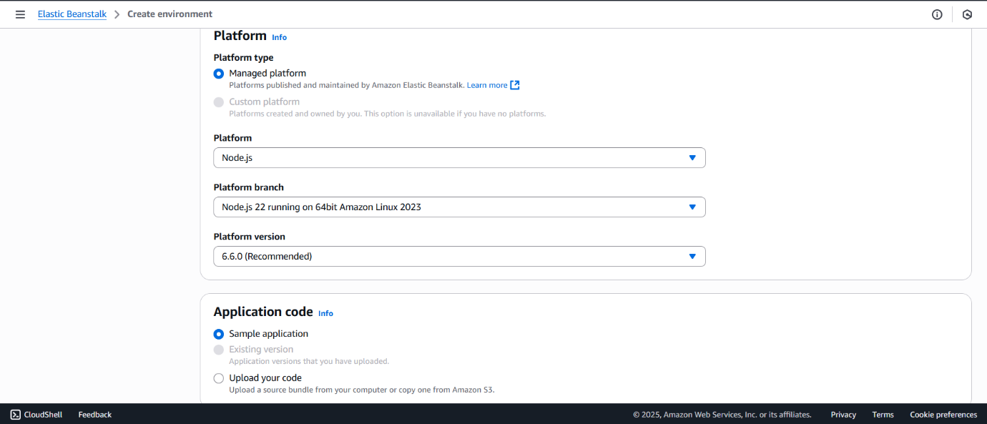

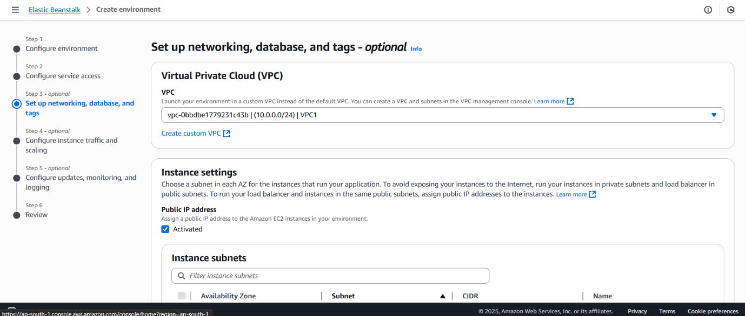

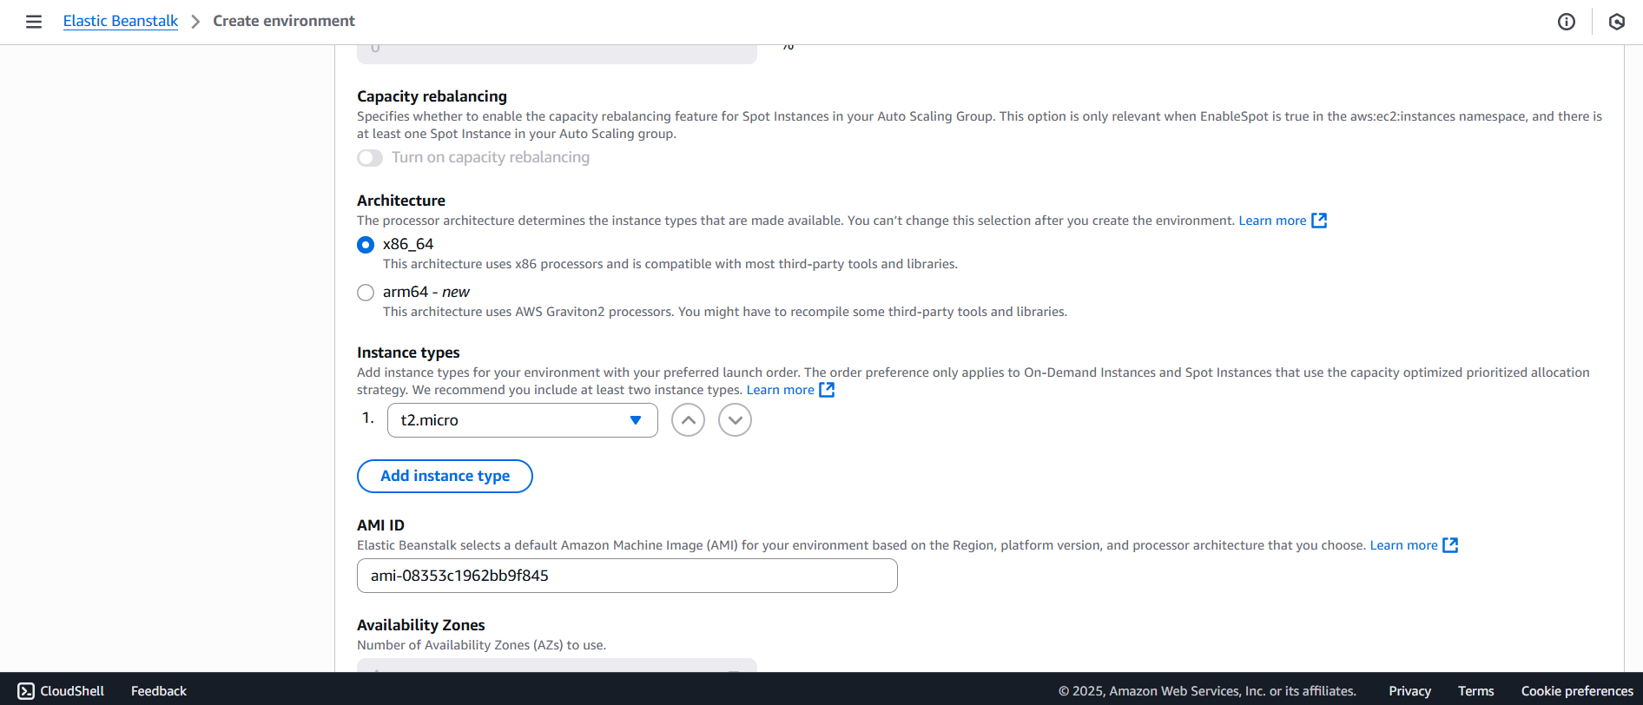

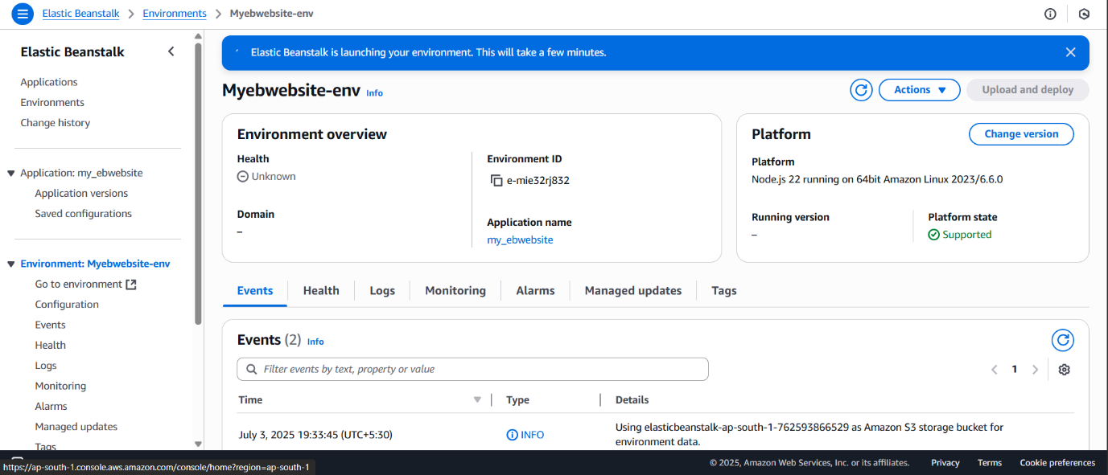

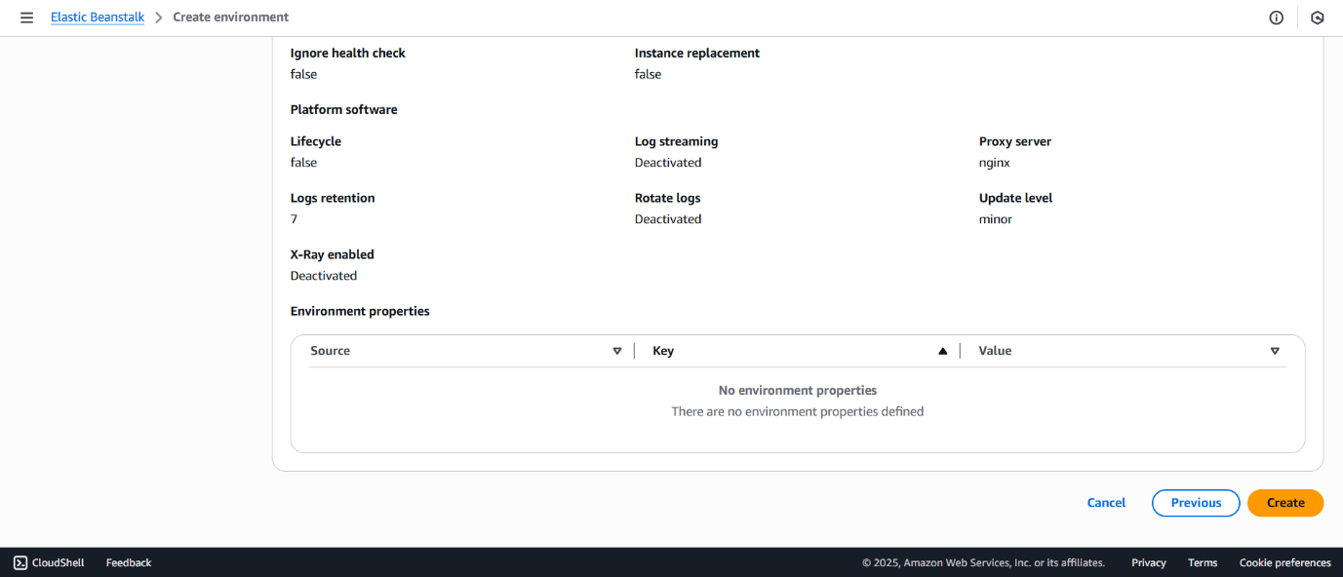

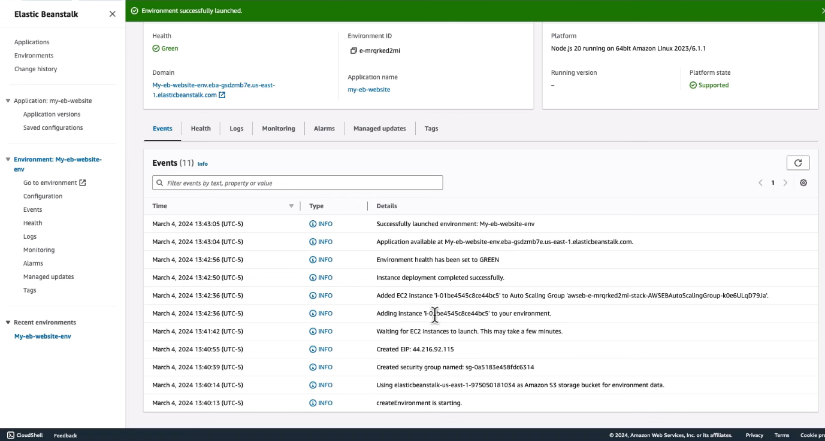

**Uses and Application of the Task**

1. **Testing Deployment Pipelines**

Before deploying a real application, using the sample application allows developers to test the entire pipeline without any code.  
This is helpful to ensure that all configurations, permissions, and environment settings are correctly in place.  
It acts as a sandbox environment where one can practice deploying, scaling, and terminating environments with zero risk to actual applications.

1. **Preparing for Real Application Hosting**

Once familiar with Elastic Beanstalk through the default application, users can move on to deploying their own code.  
The same environment setup and deployment steps can be reused for Flask, Node.js, Java, or .NET applications.  
This transition is smooth because the user already understands how deployment works on a structural level.